9/2016
Proper Grip Handout
What you see here are the two efficient grips that are universally recommended for children to achieve: the tripod grip and the quadropod grip.

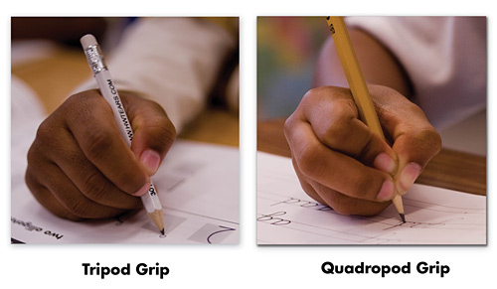

For the tripod grip, the thumb, pointer, and middle finger work together to hold a writing tool.

For the quadropod grip, four fingers work together to stabilize the writing tool. Notice how the pencil rests on the ring finger and this provides additional support.

You might observe children holding their crayon or pencil with too many fingers or placing their thumbs on top of their fingers, or their fingers on top of their thumbs. If you notice this, you will need to help children form the proper grip to help them with the mechanics of writing and ultimately, to become better writers.

Learning the proper pencil grip can be a little tricky for kids–and it’s so important for handwriting! If they learn how to grip the pencil incorrectly and are allowed to continue without correction, it is a hard habit to break. Thankfully, there are methods to correcting pencil grip in kids. It will take some work and reminders, but it can be done. Here are a few favorite tricks for correcting proper pencil grip.
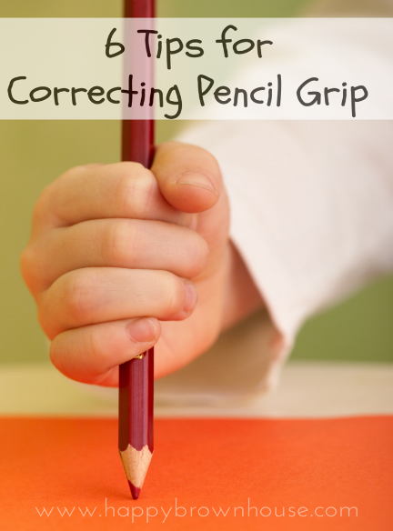

Use Smaller Writing Tools
Try giving your child a golf pencil, broken crayon/chalk, or crayon rocks for a twist on the traditional. The smaller size of these items naturally requires children to use the correct pencil grip because there is less surface area. Golf pencils are often even too long and can be broken in half.
The Sock Method
It may look silly, but the sock trick is really easy. Just take an old sock and cut two holes. Have your child put the sock on their hand, putting their thumb and index finger through the holes. The rest of the hand can curl up together and take a nap inside.
The Pom Pom Method
Place a pom pom or another small item in between the last two fingers and your child’s palm. This will force your child to keep those extra fingers under and out of the way while they hold their pencil. You can also use a penny or any small item.
The “OK” Method
Tell your child to make the OK sign with their fingers. Tell them to open the circle a little and place the pencil in between their fingers. Then, tell them to curl their other fingers under.
The Pinch & Flip Method
Tell your child to lay the pencil in front of them with the point of the pencil pointing away from them. Tell them to pick up their pencil with their thumb and index finger–this is the pinch part. Then, have them gently push the pencil so it flips around and rests properly. Easy!
After they’ve been shown the correct grip, gentle reminders are appropriate. It may require you to do some “hand-over-hand” instruction (where you physically help them get their pencil grip correct), but with time, they will start to get the hang of it. If your child is having a hard time at the beginning of holding a pencil and writing, I would suggest taking a step back and working on some fine motor skills activities to strengthen their finger muscles and playfully practice pencil holding techniques. Many fine motor skills activities naturally encourage the proper tripod grip.
Videos showing the way to do all of the above methods can be viewed on www.happybrownhouse.com
Other suggestions for guiding grip at the correct placement on pencil:
- Wrap a sticker or rubber band on pencil and remind child that this is where his fingertips need to be when holding a pencil.
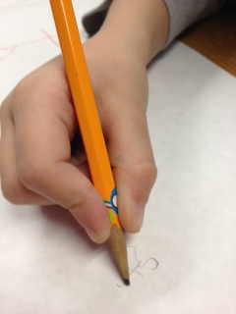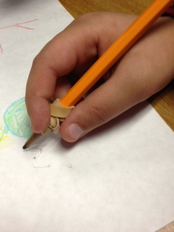

- For better horizontal alignment of pencil in hand, draw a smiley face on the web space so your child knows where his pencil should rest when writing.
